HOTEL REGISTRATION FORM
Block code: Eurocrim 2018

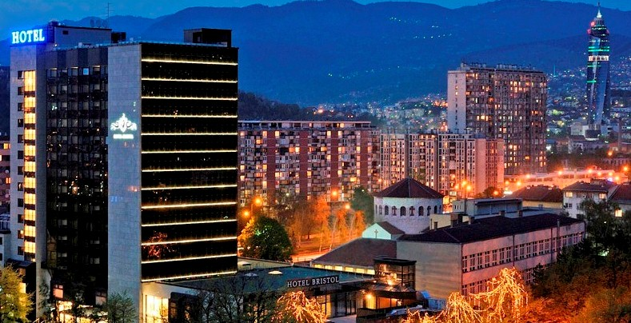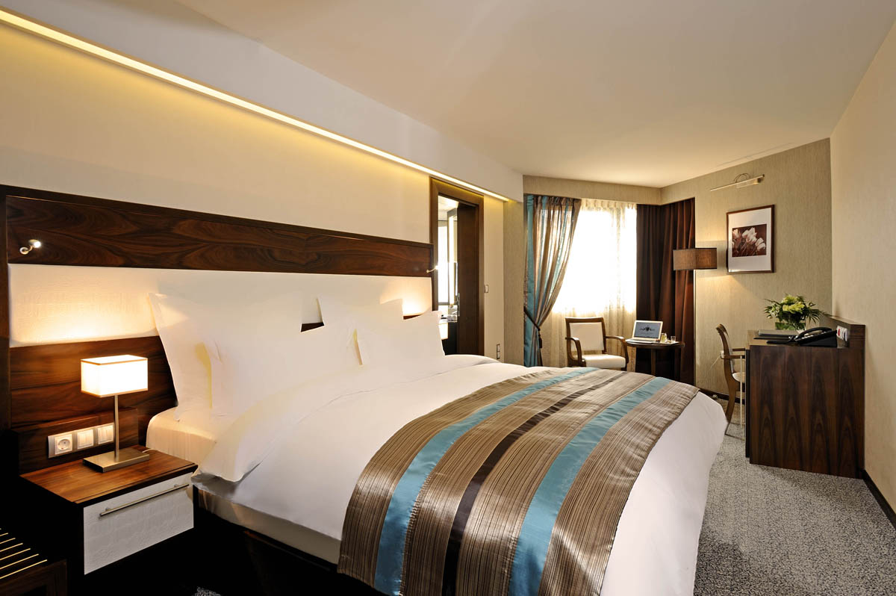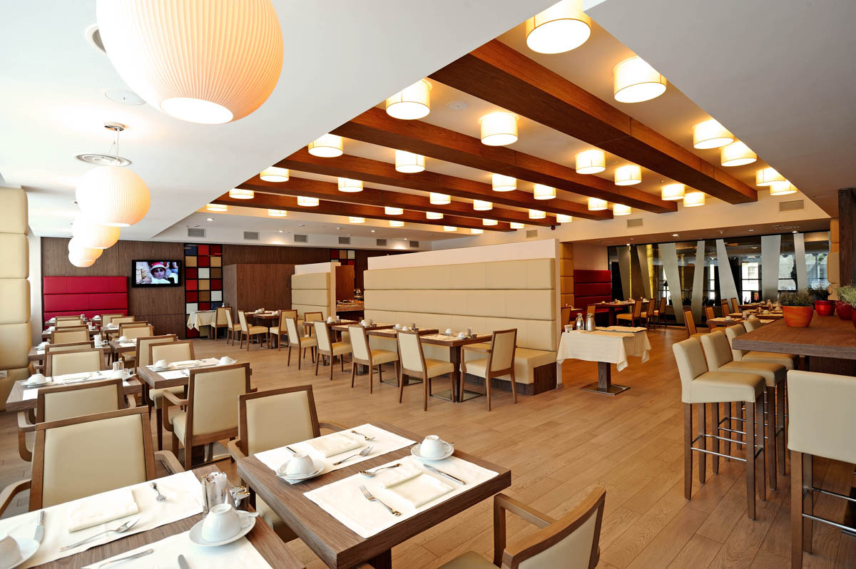

Family  name: | First  name:
Address:

Country:

Tel/Fax

Arrival date: | Departure date:

Cross the room type required

Room type | Rate KM | Total nights | No. of rooms
Superior room – single occupancy
Deluxe double room

Deluxe triple room

The above rates are understood per room per night, include buffet breakfast, mini bar, use of swimming pool, fitness center, hamam, sauna, internet access and VAT.

Additional surcharge of 2 BAM (approx. 1 EUR) per person per night applies.

Check-in time: 14:00 hours Check-out time: 12:00 hours

PAYMENT GURANTEE (please cross):
In order to guarantee accommodation please supply your credit card details:
Credit card type (please cross):

Credit card number:

Card holder:

CANCELLATION POLICY: Reservations can be cancelled without penalties 24 hours prior to arrival. In case of no-shows or late cancellations, the Hotel reserves the right to charge the full first night. All reservations will be confirmed on request and upon availability.

Please send this form to:

Reservations – Hotel Bristol Sarajevo
E-mails: reservations@bristolsarajevo.com
T. +387 33 705 005 F. +387 33 705000

